Planning Dept.;
Councilors Bushor, Paul: Ordinance Com.

Nine

COMPREHENSIVE DEVELOPMENT ORDINANCE
#ZA-09-04 re: Downtown Transition Height Limits

That the Comprehensive Development Ordinance of the Code of Ordinances of the City of Burlington be and hereby is amended by amending Sec. 4.4.1(a) and Map 4.4.1-1 and Sec. 4.4.1(d) thereof to read as follows:

Sec. 4.4.1 Downtown Mixed Use Districts

(a) Purpose: As written.

1. As written.

2. As written.

A. D-T North: As written.
- D-T Main St. South: Land within 150-feet from the centerline of Main Street along the south side of Main Street Lots of record as of January 1, 2007 with frontage along the south side of Main St. in that portion of the Downtown Transition District (DT) between Main St. to King St. and from Battery Street to South Winooski Avenue;
- D-T South: Properties with frontage on the east side of South Winooski Avenue from Buell Street to Main Street, the west side of South Union St from Bradley Street to Main Street, both sides of Main St from South Union St. to South Winooski Avenue, both sides of St. Paul Street between Main and Maple Street, and the south side of Main Street from South Union St. to Battery Street not otherwise included in the D-T Main St. South subdistrict above; and,
2

COMPREHENSIVE DEVELOPMENT ORDINANCE
#ZA-09-04 re: Downtown Transition District (DT)

D. D-T Maple South: As written.

- As written.

- As written.

- As written.

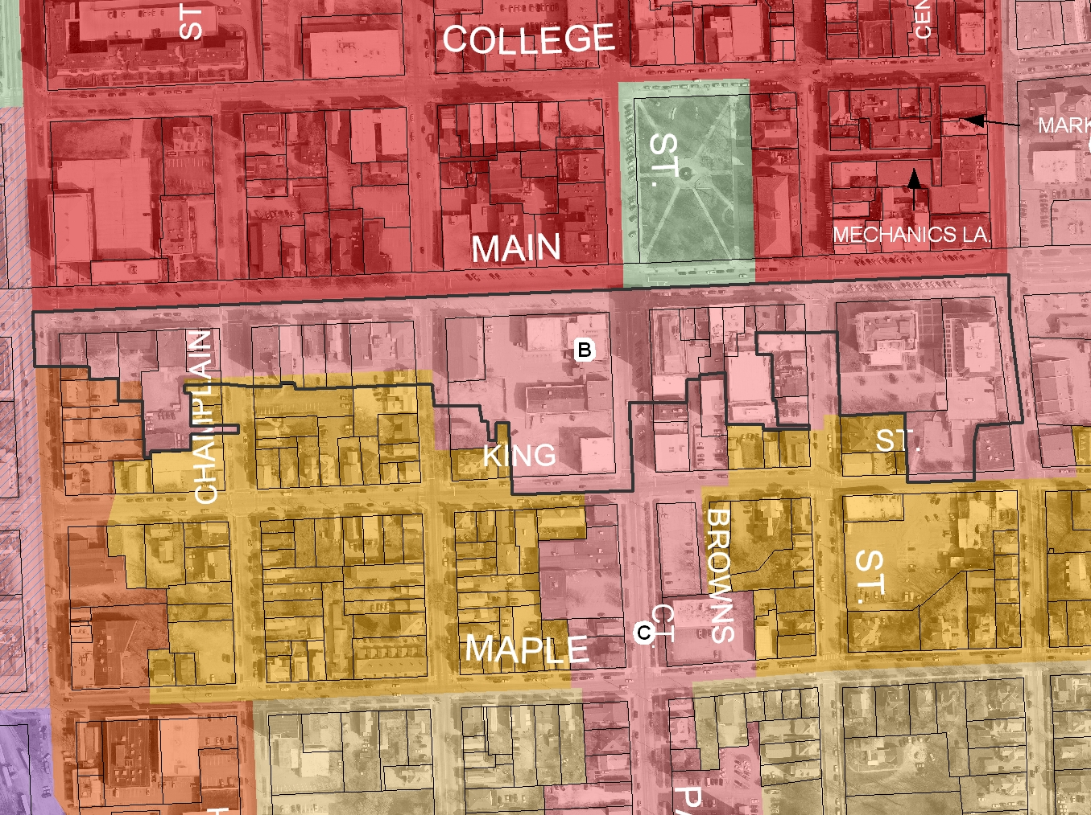

Map of D-T Main St. South as proposed

- Dimensional Standards and Density. As written.
- As written.
- District Specific Regulations,
1. Use Restrictions. As written.
2. Public Trust Restrictions. As written.
3. Facades and Setbacks on side and Rear Property Lines. As written.
3

COMPREHENSIVE DEVELOPMENT ORDINANCE
#ZA-09-04 re: Downtown Transition District (DT)

4. Building Height Setbacks
A. Principal View Corridors. As written.
B. Church Street Buildings. As written.
C. Side Street Building Height:
For the purposes of maintaining the residential character and scale of buildings along the north side of King St., on both sides of South Champlain Street, St. Paul Street, Pine Street and Church Street and the west side of South Winooski Ave. beyond 150 feet south of the center line of Main Street, as illustrated (attached), the maximum height of any building fronting on these streets shall be limited to 65 feet, inclusive of any available height bonuses, within 85 feet of the edge of the public right-of-way.
5. Lake Champlain Waterfront Setback. As written.
6. Development Bonuses/Additional Allowances. As written.

* Material stricken out deleted.
** Material underlined added.

lb/kas/c: Ordinances 2008/Zoning Amendment #ZA-09-04 re Downtown Transition Height Limits Sec. 4.4.1(a) & (d)
12/30/08; 3/6/09

