Burlington Comprehensive Development Ordinance
Attached illustration for ZA-09-04 Downtown Transition Height Limits
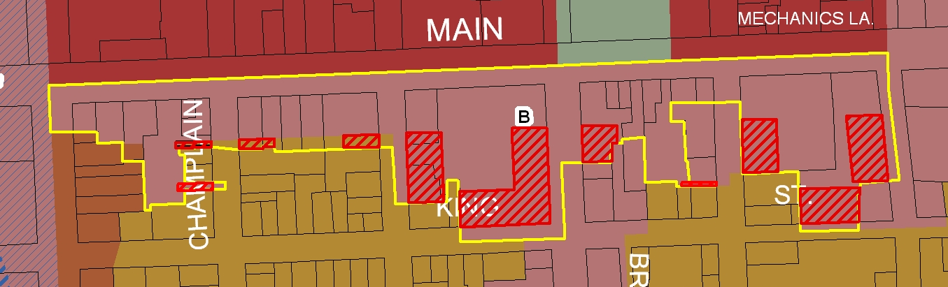

- Bright Line: D-T Main St. South boundary (properties with frontage on Main Street between S. Winooski Ave. and Battery St.)
- Hatched Area: Side Street Building Height Setbacks - (area within 85-feet of the public right-of-way of the side street and beyond 150-ft south of the Main Street centerline)

 | Max. Height | Max Height  with bonuses
B. D-T Main St. South:  (properties with frontage on Main Street between S. Winooski Ave. and Battery St.) | 65 feet | 105 feet
Side Street Building Height Setbacks  (area within 85-feet of the public right-of-way of the side street and beyond 150-ft south of the Main Street centerline) | 65 feet | 65 feet

