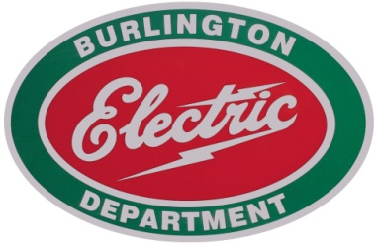

585 Pine Street • Burlington, VT 05401-4891
802/658-0300 • 802/865-7386 (TTY/Voice) • Fax: 802/865-7400

Date: March 20, 2013

To: Burlington City Council

From: John Irving

Re: Turbine Maintenance Contract for Years 2013 - 2015

The current contract for maintenance for the McNeil turbine generator has expired. Historically, we have had the original equipment manufacturer , OEM, (Alstom) perform this maintenance, due to the specialized tools, talents and parts necessary for our Swiss turbine. In accordance with Burlington purchasing procedures, we solicited competitive bids for this work. During the next three years, there are no major overhauls planned, only the minor annual overhauls as well as the annual inspections.

Requests for proposals (RFP’s) were sent to four turbine maintenance entities for competitive bidding regarding McNeil’s turbine contract for years 2013 through 2015. The request was sent to Alstom Power Service, Turbine Generator Maintenance, Turbo Care/Siemens Inc., and Power Plant Services.

Turbine Generator Maintenance did not supply a proposal in the required timeframe, nor did Power Plant Services. Turbo Care supplied a lump sum proposal for annual inspections and time and material rates for annual outages. Alstom supplied a lump sum proposal both for annual inspections and for annual outages, with a breakdown of pricing.

Comparing annual inspection proposed pricing from the two Bidders, Alstom was the low bidder at $12,200 per annual inspection versus Turbo Care’s proposed price of $15,170 per annual inspection. Comparing Alstom’s and Turbo Care’s labor rates, they are similar though there was some variance. For example, Alstom’s labor rate for Mill Wright Foremen is $72.50/hr. while Turbo Care’s labor rate for a Mechanical Labor Supervisor is $100/hr. Another example, Alstom’s labor rate for a Specialized Advisor is $264/hr. while Turbo Care’s labor rate for a Specialty Engineer is $260/hr. or a Technical Field Advisor is $200/hr.

Based on the lowest evaluated cost and that Alstom is the OEM, I recommend that we award the turbine maintenance contract to Alstom Power Service, Alstom Proposal No. L0057 Rev. H. We have had an excellent history with this company in providing these services to McNeil Station.

Do not hesitate to contact me with any questions you may have.

