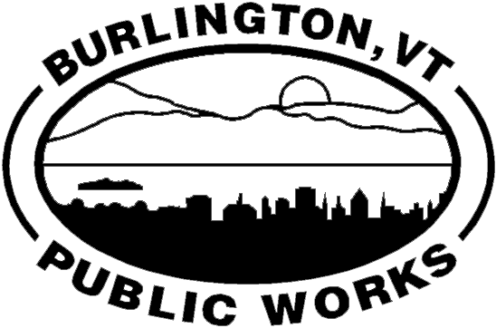

Memo

Office of Plangineering
645 Pine Street, Suite A
Burlington, VT 05402
802.863.9094 P
802.863.0466 F
802.863.0450 TTY
www.dpw.ci.burlington.vt.us

Steven Goodkind, P.E.
DIRECTOR OF PUBLIC WORKS
City Engineer

Date: June 5, 2013
To: City Council

From: Nicole Losch, Transportation Planner

Subject: Authorization to Enter Agreements to Provide Local Match

BACKGROUND
The Chittenden County Regional Planning Commission (CCRPC) receives metropolitan planning funds from the Federal Highway Administration (FHWA) to support activities related to surface transportation planning. The CCRPC allocates these funds through their annual Unified Planning Work Program (UPWP). There is an additional mid-year adjustment, which modifies the scope of work to account for unanticipated planning activities.

The Department of Public Works (DPW) consults existing city plans and other city departments to identify projects in need of transportation planning. Projects are submitted during the UPWP development schedule, and then prioritized by the CCRPC with consultation from DPW.

UPWP projects are approved by the CCRPC’s Transportation Advisory Committee (TAC) and Board of Directors, on which Burlington has one representative on each committee. Projects often proceed with work provided by a consultant recommended from the CCRPC’s on-call list. The city agrees to pay the CCRPC for the local match required (usually 20 percent) for locally managed projects, for the consultant’s work on the projects.

At the June 3, 2013 meeting of the Board of Finance, the DPW requested and received approval to execute two agreements to provide local match for planning of two projects currently underway. Although the projects are underway, no local funds have been expended on these projects. In addition, no budget amendment is necessary to expend funds for these projects, which are programmed within the Street Capital Local Match.

REQUEST FOR APPROVAL

Railyard Enterprise Project
The purpose of this project is to develop a network of multimodal transportation infrastructure improvements, which incorporate the principles of Complete Streets, to support economic development in the area; improve livability of the surrounding neighborhoods; enhance multimodal travel connectivity between the Pint Street corridor to and the Burlington Waterfront South area; and improve intermodal connections to the Burlington Railyard.
Total project cost: $162,724
CCRPC agrees to provide FHWA funds for 80% of the project cost: $130,179
We request authorization to execute the local match agreement to provide the 20% local match, in the amount of $32,545.

North Avenue Corridor Study
This project will facilitate a study of North Avenue between Plattsburg Avenue and North Street and solicit public feedback to identify transportation improvements to the corridor. The project kick-off meeting for the Advisory Committee is scheduled for early June. The first public meeting is anticipated to be held in July.
Total project: $115,848
CCRPC agrees to provide FHWA funds for 80% of the project cost: $92,678
We request authorization to execute the local match agreement to provide the 20% local match, in the amount of $23,170.

