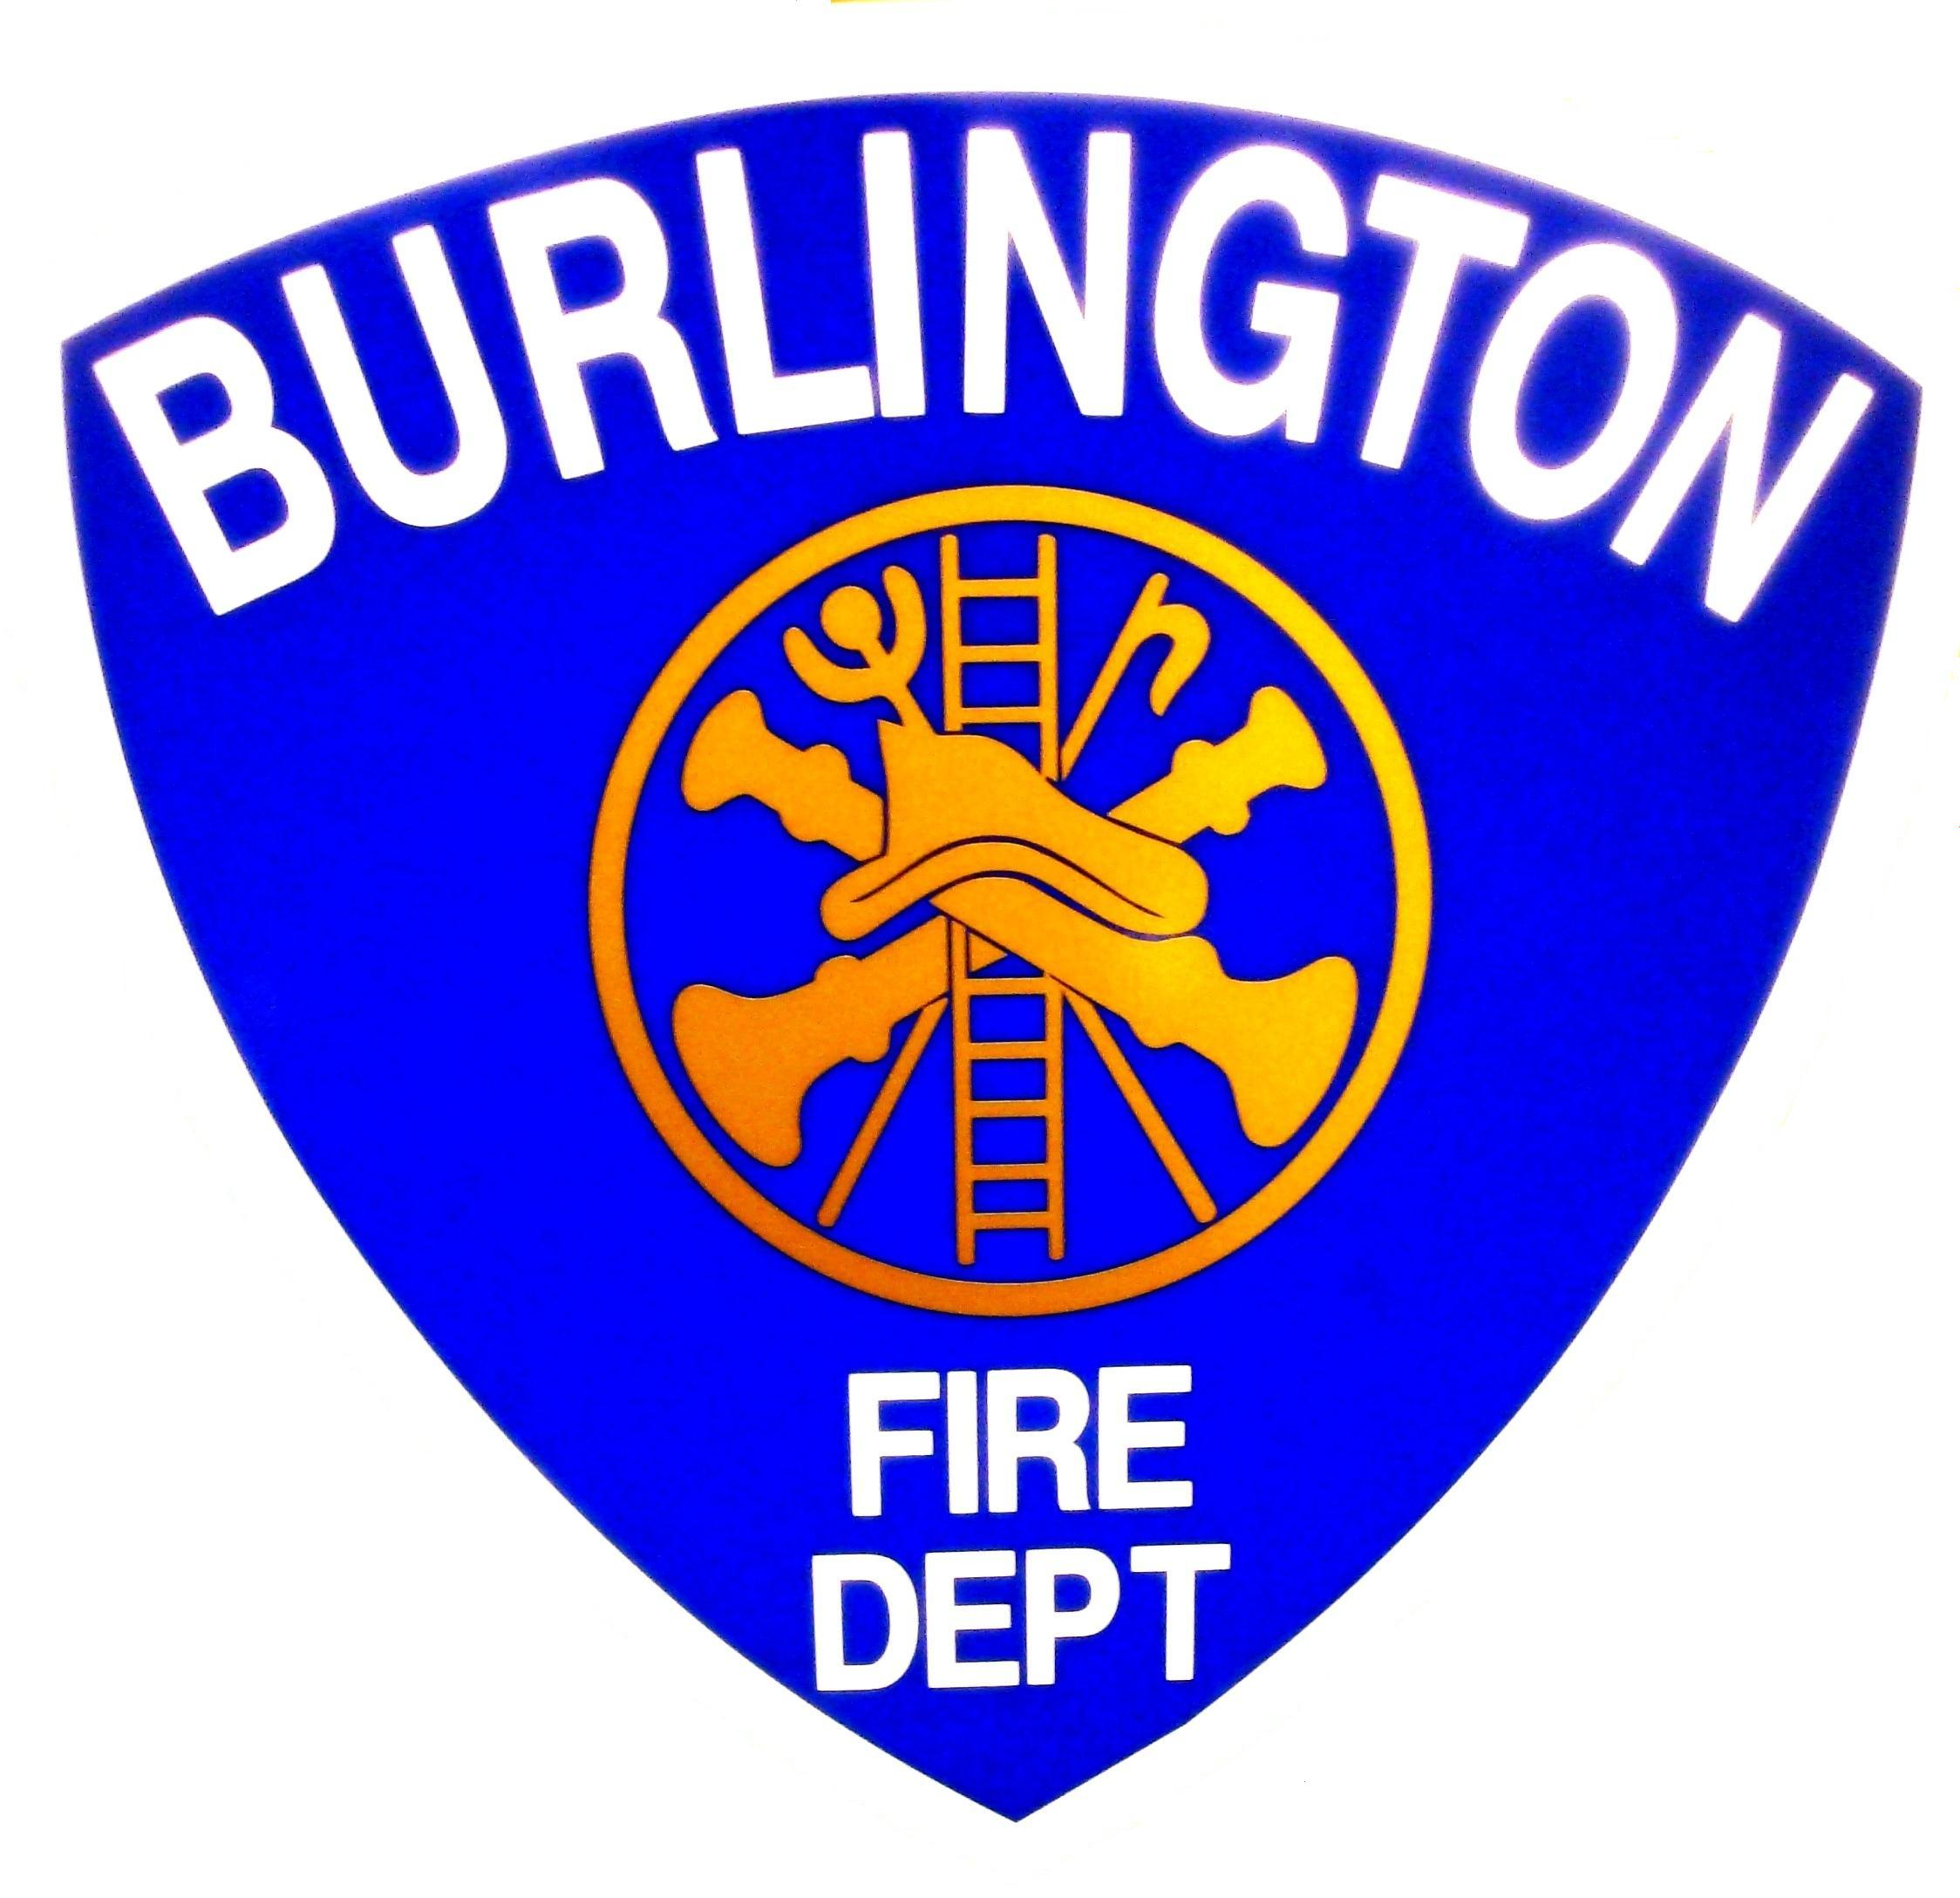  Michael E. O'Neil  Chief Engineer | Burlington Fire Department  Office of the City Fire Marshal  Battalion Chief Terence J. Francis, Fire Marshal  132 North Avenue, Burlington Vermont 05401  (802) 864-5577 Fax (802)658-7665


The tragic events at the Station Nightclub in West Warwick, RI, in 2003 dramatically illustrated that fires in assembly occupancies are some of the most deadly when the proper features, systems and construction materials are not present. Nightclubs, theaters and auditoriums differ from office buildings because they contain a large number of people in one place. The state fire & building safety code provisions mandate that a considerable number of safety systems and features be present in order to keep everyone safe in the event of fire.

REQUIREMENTS FOR PUBLIC ASSEMBLY OCCUPANCIES IN

The City of Burlington

The Burlington Fire and Police Departments take safety in places of assembly very seriously, and the City conducts random occupancy inspections frequently. Places of assembly undergo annual inspections by the Fire Marshal's Office, and each is required to display the occupancy load certificate which is issued by this office. The certificate is issued only after all violations have been corrected, and it may be subsequently revoked by the Fire Marshal's Office.

All establishments which serve alcohol on premises in the City of Burlington must be fully compliant with all requirements of the fire code as a condition of their liquor license. Establishments which fail to comply are subject to legal actions which may include inspection fees, fines, suspension or revocation of their liquor license and occupancy load certificate, closure and even criminal charges.

Occupant Load.
The occupant load, in number of persons for whom means of egress and other provisions are required, shall be determined on the basis of the occupant load factors of Table 7.3.1.2 that are characteristic of the use of the space or shall be determined as the maximum probable population of the space under consideration, whichever is greater.

Table 7.3.1.2 Occupant Load Factor
Use sqft2 (per person)
Concentrated use, without fixed seating | 7 net
Less concentrated use, without fixed seating | 15 net
Bench-type seating | 1 person/18  linear in.
Fixed seating | Number of fixed seats
Stages | 15 net

The authority having jurisdiction shall be permitted to establish the occupant load as the number of persons for which the existing means of egress is adequate, provided that measures are established to prevent occupancy by a greater number of persons.

Means of Egress Requirements.
Assembly occupancies with occupant loads of 600 or fewer shall have two separate means of egress.

Assembly occupancies with occupant loads greater than 600 but fewer than 1000 shall have three separate means of egress.

Access and egress routes shall be maintained so that any individual is able to move without undue hindrance, on personal initiative and at any time, from an occupied position to the exits.

Access and egress routes shall be maintained so that crowd management, security, and emergency medical personnel are able to reach any individual at any time, without undue hindrance.

In every occupied building or structure, means of egress from all parts of the building shall be maintained free and unobstructed. No lock or fastening shall be permitted that prevents free escape from the inside of any building

Means of egress, shall be illuminated in accordance with the code Emergency lighting shall also be provided

Means of egress shall be provided with signs

The building owner or agent shall inspect all means of egress in assembly occupancies identified as bars, dance halls, discotheques, nightclubs or where festival seating is used, to ensure all means of egress are maintained free of

obstructions, and correct any deficiencies found, prior to each opening of the building to the public. A record, available to the AHJ, shall be kept of all inspections, deficiencies found, and actions taken to correct them.

Detection, Alarm, and Communications Systems.
Assembly occupancies with occupant loads of more than 300 and all theaters with more than one audience-viewing room shall be provided with an approved fire alarm system

In assembly occupancies with occupant loads of more than 300, automatic detection shall be provided in all hazardous areas that are not normally occupied, unless such areas are protected throughout by an approved, supervised automatic sprinkler system

Ignition sources
No open flame devices or pyrotechnic devices shall be used in any assembly occupancy, unless otherwise permitted by the following:

(1) Pyrotechnic special effect devices shall be permitted to be used on stages before proximate audiences for ceremonial or religious purposes, as part of a demonstration in exhibits, or as part of a performance, provided that both of the following are met:

(a) Precautions satisfactory to the authority having jurisdiction are taken to prevent ignition of any combustible material.

(b) Use of the pyrotechnic device complies with NFPA 1126, Standard for the Use of Pyrotechnics before a Proximate Audience.

(2) Flame effects before an audience shall be permitted in accordance with NFPA 160, Standard for Flame Effects Before an Audience.

(3) Open flame devices shall be permitted to be used in the following situations, provided that precautions satisfactory to the authority having jurisdiction are taken to prevent ignition of any combustible material or injury to occupants:
(a)* For ceremonial or religious purposes
(b) On stages and platforms where part of a performance
(c) Where candles on tables are securely supported on substantial noncombustible bases and candle Flame is protected

Furnishings & Contents
Interior finish shall be in accordance with Section 10.2. of NFPA 101

Combustible scenery of cloth, film, vegetation (dry), and similar materials shall meet the requirements of NFPA 701

Scenery and stage properties on thrust stages shall be of either noncombustible or limited-combustible materials.
On-site fire protection
Any assembly occupancy used or capable of being used for exhibition or display purposes shall be protected throughout by an approved automatic sprinkler system where the exhibition or display area exceeds15,000 sq ft.

Sprinkler Systems
Buildings containing assembly occupancies with occupant loads of more than 300 shall be protected by an approved, supervised automatic sprinkler system in accordance with the Code or a assembly occupancy where the occupant load exceeds 100, identified as bars, dance halls, discotheques, nightclubs or where festival seating is used, shall be protected throughout by an approved, supervised, automatic fire sprinkler system.

Existing Assembly Occupancies where the occupant load exceeds 100, identified as bars, dance halls, discotheques, nightclubs or where festival seating is used, shall be protected throughout by an approved, supervised, automatic fire sprinkler system ( see effective dates) -

To achieve an orderly transition of the requirement for sprinklers in existing assembly occupancies shall take effect;
October 1, 2007 where the occupant load exceeds 300

And October 1, 2009 where the occupant load exceeds 100

Occupant Load Posting.

Every room constituting an assembly occupancy and not having fixed seats shall have the occupant load of the room posted in a conspicuous place near the main exit from the room.

Approved signs shall be maintained in a legible manner by the owner or authorized agent.

Signs shall be durable and shall indicate the number of occupants permitted for each room use.

This sheet is designed to promote fire prevention, code compliance and to enhance the public safety of all Vermonters. This sheet provides a detailed overview of one common issue and is not an all-inclusive list of state laws or additional code requirements that may apply. For additional information or details you should contact an Asst. State Fire Marshal in your regional office of the Division of Fire Safety. This sheet was developed as an educational resource with information provided from the National Fire Protection Association (NFPA)

Means of Egress Inspection
The building owner or agent shall inspect the means of egress to ensure it is maintained free of obstructions, and correct any deficiencies found, prior to each opening of the building to the public.

The building owner or agent shall prepare and maintain records of the date and time of each inspection on approved forms, listing any deficiencies found and actions taken to correct them.

