Burlington Fire Department
Office of the City Fire Marshal
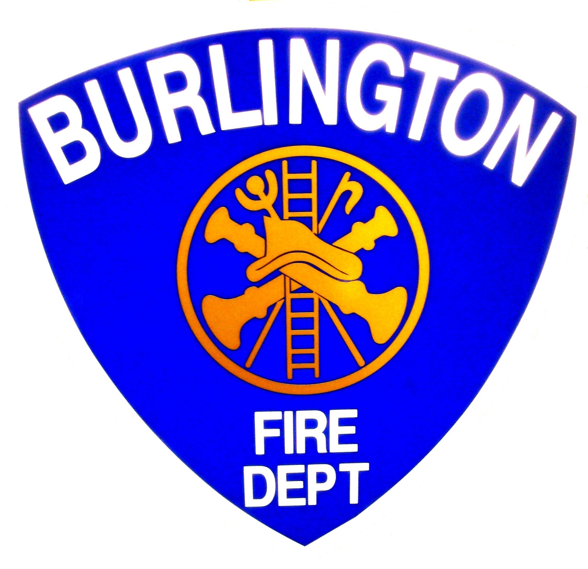
Michael E. O'Neil
Chief Engineer
Michael E. O'Neil
Michael E. O'Neil
132 North Avenue, Burlington Vermont 05401
(802) 864-5577 Fax (802)658-7665
Burlingtonfire.net
Seasonal Decorations and Christmas Trees

NFPA 1 - 10.14 Combustible Vegetation.

Combustible vegetation, including natural cut Christmas trees, shall be in accordance with Table 1:10.14.1

Combustible Vegetation: In other than Health Care, Detention and Correctional occupancies, combustible vegetation, including natural cut Christmas trees otherwise prohibited under table 10.14.1 shall be permitted when located in areas protected by an approved automatic fire sprinkler system.

Provisions for Flame Resistance or Fire Retardance.
Table 10.14.1.as amended under
Vermont Fire & Safety Code
Occupancy | No trees  Permitted | Cut tree permitted with sprinkler system | Cut tree permitted without  Sprinkler system | Balled tree  Permitted
Ambulatory Health care |  | x |  | ❒
Apartment buildings |  | Within Unit | Within Unit | ❒
Assembly |  | X
Board and Care |  | X
Business |  | ❒ |  | ❒
Day-care |  | ❒ |  | ❒
Detention and Correctional | ❒
Dormitories |  | X
Educational |  | X
Health care | X
Hotels |  | X
Industrial |  | ❒ | ❒ | ❒
Lodging and rooming |  | ❒ |  | ❒
Mercantile |  | ❒ |  | ❒
One and Two Family |  | ❒ | ❒ | ❒
Storage |  | ❒ | ❒ | ❒

Artificial vegetation and artificial Christmas trees shall be labeled or otherwise identified or certified by the manufacturer as being fire retardant. 1: 10.14.3.1

Such fire retardance shall be demonstrated by each individual decorative vegetation item, including any decorative lighting, in an approved manner. 1:10.14.3.2

Vegetation and Christmas trees shall not obstruct corridors, exit ways, or other means of egress. 1:10.14.4

Only listed electrical lights and wiring shall be used on natural or artificial combustible vegetation, natural or artificial Christmas trees, and other similar decorations. 1:10.14.5

Electrical lights shall be prohibited on metal artificial trees. 1:10.14.6

Open flames such as from candles, lanterns, kerosene heaters, and gas-fired heaters shall not be located on or near combustible vegetation,
Christmas trees, or other similar combustible materials. 1:10.14.7

Combustible vegetation and natural cut Christmas trees shall not be located near heating vents or other fixed or portable heating devices that could cause it to dry out prematurely or to be ignited. 1:10.14.8

Provisions for Natural Cut Trees.

Where a natural cut tree is permitted, the bottom end of the trunk shall be cut off with a straight fresh cut at least ½ in. (13 mm) above the end prior to placing the tree in a stand to allow the tree to absorb water. 1:10.14.9.1

The tree shall be placed in a suitable stand with water.10.14.9.2

The water level shall be maintained above the fresh cut and checked at least once daily. 1:10.14.9.3

The tree shall be removed from the building immediately upon evidence of dryness. 1:10.14.9.4

Electrical Fire Safety.

Extension cords shall be plugged directly into an approved receptacle, power tap, or multiplug adapter and shall, except for approved multiplug extension cords, serve only one portable appliance. 11.1.5.3.1

The ampacity of the extension cords shall not be less than the rated capacity of the portable appliance supplied by the cord. 11.1.5.3.2
The extension cords shall be maintained in good condition without splices, deterioration, or damage.11.1.5.3.3

Multiplug adapters, such as multiplug extension cords, cube adapters, strip plugs, and other devices, shall be listed and used in accordance with their listing. 1:11.1.5.1

Extension cords and flexible cords shall not be affixed to structures; extend through walls, ceilings, or floors, or under doors or floor coverings; or be subject to environmental or physical damage. 1:11.1.5.3.5

Temporary electrical power and lighting installations shall be permitted for a period not to exceed 90 days for holiday decorative lighting and similar purposes. [70:527.3(B)] 1:11.1.6.4

