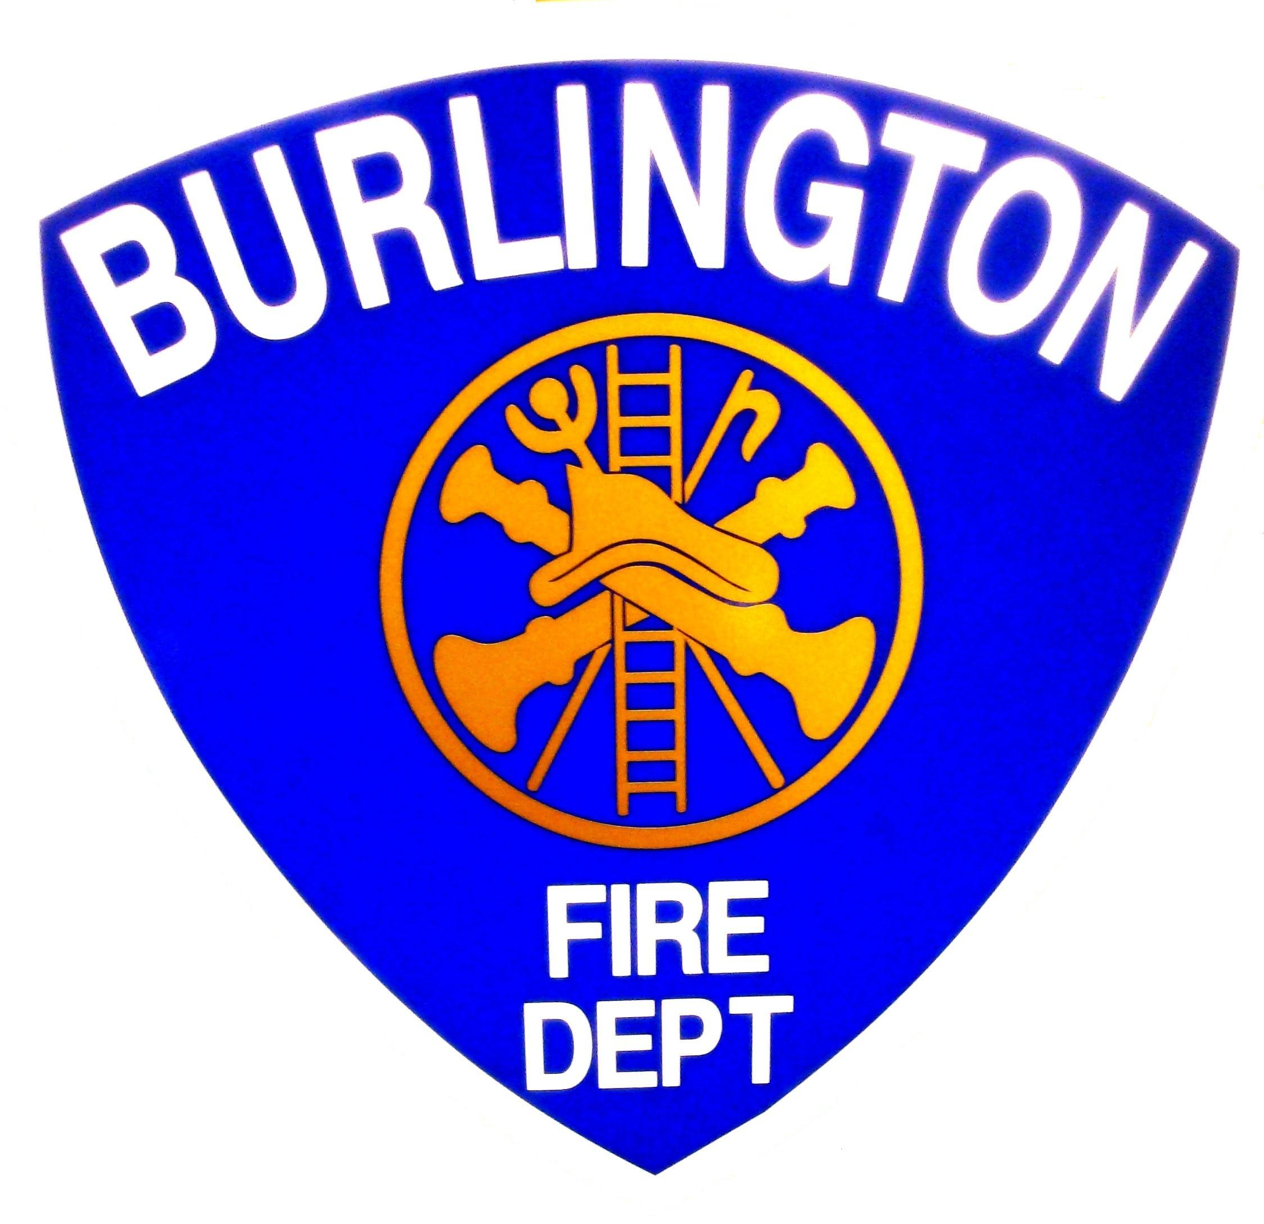
Burlington Fire Department
Office of the City Fire Marshal
132 North Avenue, Burlington Vermont 05401
(802) 864-5577 Fax (802)658-7665
Burlingtonfire.net

CARBON MONOXIDE ALARMS

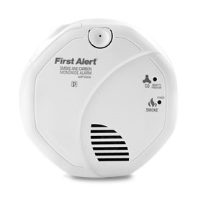

Unintentional carbon monoxide (CO) poisoning sends an estimated 10,000 people to the hospital emergency rooms for treatment each year nationwide, and claims more than 200 lives. Heating appliances that are not working properly are the major cause of unintentional carbon monoxide poisoning in Vermont. Other common sources include emergency generators or space heaters and motor vehicles left running in attached garages. During 2001-2004 there were over 800 CO incidents reported by fire departments in Vermont including 6 unintentional deaths from CO poisoning.

Carbon Monoxide Alarms (Detectors)
CO alarms are very reliable and provide excellent protection from CO. The installation of CO alarm gives a warning to people in a building of unhealthy or dangerous levels of CO before the symptoms of CO poisoning occur.

A CO alarm should be centrally located outside of each sleeping area in the immediate vicinity of the bedrooms.

Each CO alarm should be located on the wall, ceiling, or other location as specified in the manufacturers installation instructions that accompany the unit.

A CO detector is not designed to detect smoke or heat.
A CO detector is not a substitute for a properly installed smoke detector. Combination smoke detector and CO detectors are available and should also be installed in accordance with the manufacturers instructions.

It is very important to be aware of the early signs of CO poisoning. Exposure to CO can mimic flu systems - headaches, dizziness, disorientation, nausea and fatigue. Higher levels of exposure will result in disorientation and drowsiness, leading to unconsciousness and death. Often the symptoms will be less when the person exposed to carbon monoxide leaves the building, only to have the symptoms reoccur when the person re-enters the building.

The law specifies that beginning July 1, 2005 new owner occupied single-family dwellings, and dwellings that are sold or transferred, must have a CO alarm installed in the immediate vicinity of any bedrooms.
All newly installed CO alarms must be electrically wired in with battery back up. Carbon monoxide detectors currently installed in existing one-two family dwellings shall be permitted to be powered by any approved source until the end of their service life (5 years from date of installation for CO detectors).

Where interconnected smoke detectors exist, the CO detection shall be interconnected as well, such that a CO alarm will meet current audibility requirements as adopted in NFPA 72 for smoke alarms.

Any residential buildings in which people sleep, including hotels, motels, and tourist homes, apartments and condos whether the units are owned or leased or rented, require CO alarms.

The National Fire Protection Association standard (NFPA 720) provides guidance on required locations for CO alarms CO detectors must be centrally located outside of each separate sleeping area in the immediate vicinity of the bedrooms. If a hall is more than 40 feet (12 meters) long,

For added protection, install additional CO detectors in each separate bedroom, and on every level of your home.

Combination Smoke and Carbon Monoxide Detectors -
The law and the codes allow the use of photoelectric and carbon monoxide combination alarms

Detectors that do not work cannot provide early warning and save you from Carbon Monoxide Poisoning. Keep alarms clean, and test them weekly. Replace detectors immediately if they are not working properly.

How long will my CO alarm last?

Like most electrical devices, CO alarms wear out. The life span for a CO Alarm is about five years, after which it should be replaced.

You may want to write the purchase date with a marker on the back of your unit. That way, you'll know when to replace it. Always follow the manufacturer's instructions for replacement.

See the back of this page for more info

Requirements of the

Code of Ordinances of the City of Burlington
Sec. 13-4. Carbon monoxide (CO) detectors.
(a) Each and every dwelling, rooming house, dwelling unit or rooming unit let to another for occupancy shall meet the following requirements for Carbon Monoxide (CO) detectors/alarms:
Carbon monoxide detectors which are UL 2034 listed or approved by a nationally recognized independent testing laboratory shall be installed in all existing buildings in which people sleep, including where people rent accommodations whether for overnight or for a longer term, condominiums, multiple unit dwelling, and other occupancies in which there are rooms or spaces in which sleeping is permitted. Such installation shall be in the vicinity of the sleeping areas and on every floor of the dwelling, installed in accordance with the manufacturer's instructions and state law. All newly installed carbon monoxide alarms (detectors) in one and two family, dwellings, multiple unit dwellings, lodging or rooming houses, hotels and dormitories, or other buildings in which people sleep, shall be directly wired to a non-dedicated electrical branch circuit for the building and by battery. Carbon monoxide detectors currently installed in existing one-two family dwellings shall be permitted to be powered by any approved source until the end of their service life (5 years from date of installation for CO detectors).
(b) In all existing buildings in which people sleep, including where people rent accommodations whether for overnight or for a longer term, condominiums, or multiple unit dwelling, anyone installing smoke detectors pursuant to section 18-99 of this Code of Ordinances after the effective date of this section shall install either a combination smoke detector/carbon monoxide detector device or a combination system providing smoke and carbon monoxide detection and alarm. Such installation shall be in the vicinity of the sleeping areas and on every floor of the dwelling, installed in accordance with the manufacturer's instructions and state law.
(c) The seller of a residential dwelling transferred by sale or exchange shall certify to the buyer that the dwelling is provided with the carbon monoxide detectors required in subsection (a). This certification shall be signed and dated by the seller and filed in the land records at the time of recording the transfer. If the buyer notifies the seller within ten days by certified mail from the date of conveyance that the dwelling lacks a carbon monoxide detector or that the detector is not operable, the seller shall comply with this section within ten days of notification.

This sheet is designed to promote fire prevention, code compliance and to enhance the public safety of the residents of Burlington, Vermont. This sheet provides a detailed overview of one common issue and is not an all-inclusive list of state laws, municipal ordinances or additional code requirements that may apply. For additional information or details you should contact the Burlington Fire Department, Office of the Fire Marshal at 864-5577.
This sheet was developed as an educational resource with information provided from the National Fire Protection Association (NFPA) and the Vt Division of Fire Safety.

