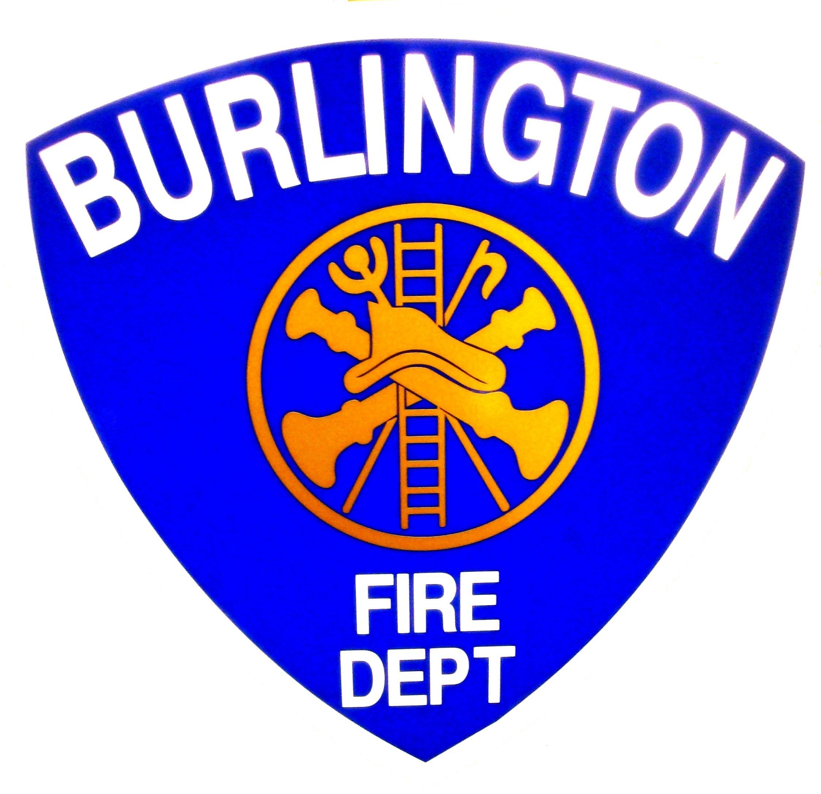
Burlington Fire Department
Office of the City Fire Marshal
132 North Avenue, Burlington Vermont 05401
(802) 864-5577 Fax (802)658-7665
Burlingtonfire.net

TAMPERING WITH FIRE SAFETY EQUIPMENT

Fire Suppression Systems and Smoke and Carbon Monoxide alarms are the best safety features you can install to protect yourself, your family and your home. In the event of a fire or CO emergency, a detector and a suppression system can save your life and those of your loved ones. The best way to prevent fatalities is by providing an early warning signal – and then putting the fire out.

Only a functioning system can protect you. Sprinkler systems, Smoke & CO alarms need to be properly installed, maintained and in a ready condition at all times. Never disable an alarm by "borrowing" its battery for another use.

Following the manufacturer's instructions, test all your smoke detectors monthly and install new batteries at least once a year. Fire suppression systems and commercial fire alarm systems must be inspected by a licensed contractor annually.

If your alarm is “chirping” this is a low battery warning, replace the battery immediately. If your alarm has a lot of false alarms it may be best to relocate it. Follow the manufacturer's instructions

Clean your smoke detectors using a vacuum cleaner or caned air without removing the detector's cover.

Never paint a smoke detector. Never obstruct a sprinkler head. Never hang anything on a sprinkler pipe.
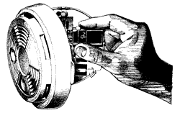
REQUIREMENTS OF THE CODE OF ORDINANCES OF
THE CITY OF BURLINGTON
Tampering with or Disabling Fire Safety Equipment.

No person shall render any portable or fixed fire-extinguishing system or device or any fire warning system inoperative or inaccessible.
[NFPA 1 -10.8.1 ]

Tampering with or disabling fire safety equipment is a criminal offense punishable by a fine of $500 and imprisonment for up to one year.
[Burlington Code of Ordinances, section 13-20]

Use and maintenance of a dwelling unit

(a) The tenant shall not create or contribute to the noncompliance of the dwelling unit with applicable provisions of building, housing and health regulations.
[Title 9: Chapter 137: § 4456. Tenant obligations]

This sheet is designed to promote fire prevention, code compliance and to enhance the public safety of the residents of Burlington, Vermont. This sheet provides a detailed overview of one common issue and is not an all-inclusive list of state laws, municipal ordinances or additional code requirements that may apply. For additional information or details you should contact the Burlington Fire Department, Office of the Fire Marshal at 864-5577.
This sheet was developed as an educational resource with information provided from the National Fire Protection Association (NFPA) and the Vermont Division of Fire Safety.

