Burlington Fire Department
Office of the City Fire Marshal
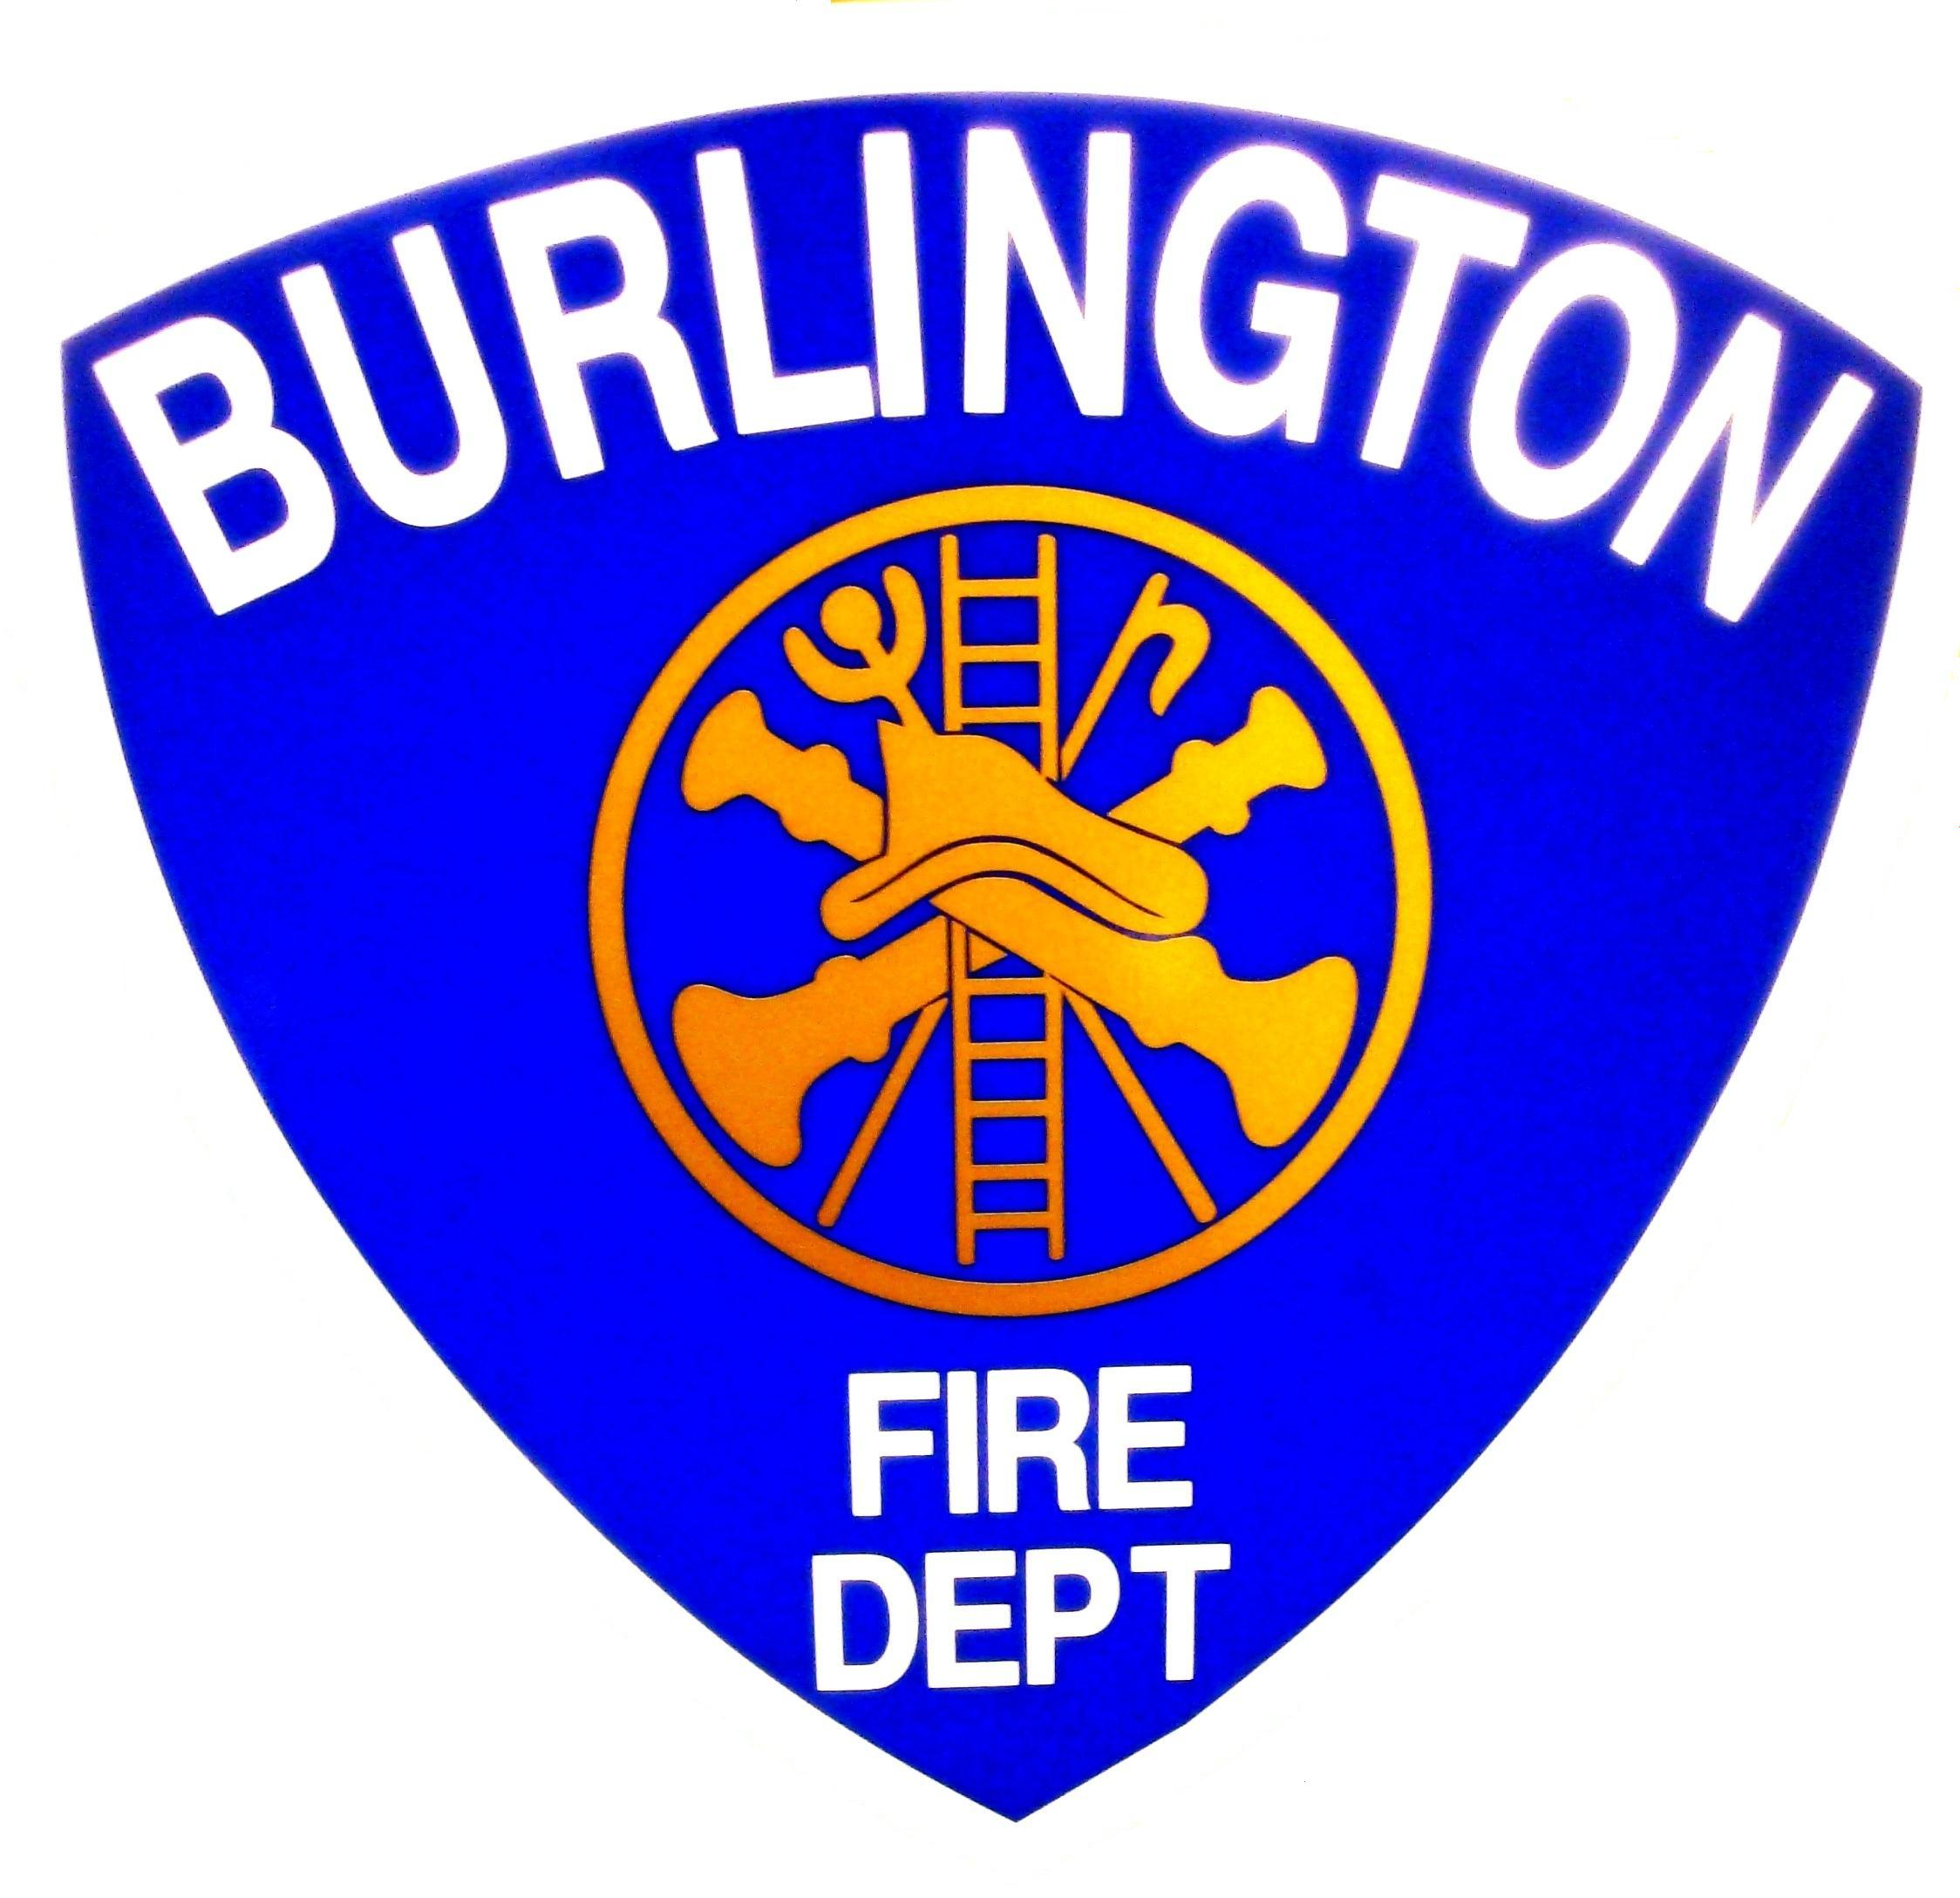
Michael E. O'Neil
Chief Engineer
Michael E. O'Neil
Michael E. O'Neil
132 North Avenue, Burlington Vermont 05401
(802) 864-5577 Fax (802)658-7665
Burlingtonfire.net
The Vermont Fire & Building Safety Code (2006 edition)* adopted the following
Ruled and Nationally Recognized Code and Standards, effective June 15, 2009
*In some cases the Burlington Code of Ordinances contains more stringent requirements

PRIMARY CODES ADOPTED
NFPA 1 | Uniform Fire Code | 2006 edition
NFPA 101 | Life Safety Code | 2006 edition
IBC | International Building Code | 2006 edition
NFPA 70 | National Electrical Code | 2008 edition
NBIC | National Board Inspection Code, National Board of Boiler & pressure Vessel Inspectors | 2004 edition
ADA | Americans with Disability Act Accessibility,28 CFR Part 36 | July 1, 1994 as revised
ASME A17.1  ASME A17.3  ASME A18.1 | Safety Code for Elevators and Escalators  Safety Code for Existing Elevators and Escalators  Safety Standard for Platform Lifts and Stairway Chairlifts | 2007 edition  2005 edition  2005 edition
IPC | International Plumbing Code | 2003 edition

Other Major Codes & Standards
For a complete listing of all adopted/referenced Codes and standards, please see the adopted rule
NFPA 10 | Standard for Portable Fire Extinguishers | 2002 edition
NFPA 13 | Standard for the Installation of Sprinkler Systems | 2002 edition
NFPA 30 | Flammable and Combustible Liquids Code | 2003 edition
NFPA 31 | Standard for the Installation of Oil-Burning Equipment | 2001 edition
NFPA 54 | National Fuel Gas Code | 2006 edition
NFPA 58 | Liquid Petroleum Gas Code | 2004 edition
NFPA 72 | National Fire Alarm Code, | 2002 edition
NFPA 73 | Residential Electrical Code | 2006 edition
NFPA 90A | Standard for the Installation of Air-Conditioning and Ventilating Systems | 2002 edition
NFPA 96 | Standard for Ventilation Control and Fire Protection of Commercial Cooking | 2004 edition
NFPA 211 | Standard for Chimneys, Fireplaces, Vents, and Solid Fuel-Burning Appliances | 2003 edition
NFPA 495 | Explosive Materials Code | 2006 edition
NFPA 914 | Code for Fire Protection of Historic Structures | 2001 edition
NFPA 1123 | Code for Fireworks Display | 2006 edition
NFPA 1124 | Code for the Manufacture, Trans., Storage and Retail Sales of Fireworks | 2006 edition
ASCE 7 | Minimum Design Loads for Buildings & Other Structures | 2005 edition
Please go to www.vtfiresafety.org for information on how to purchase the codes and standards.

