Burlington Fire Department
Office of the City Fire Marshal
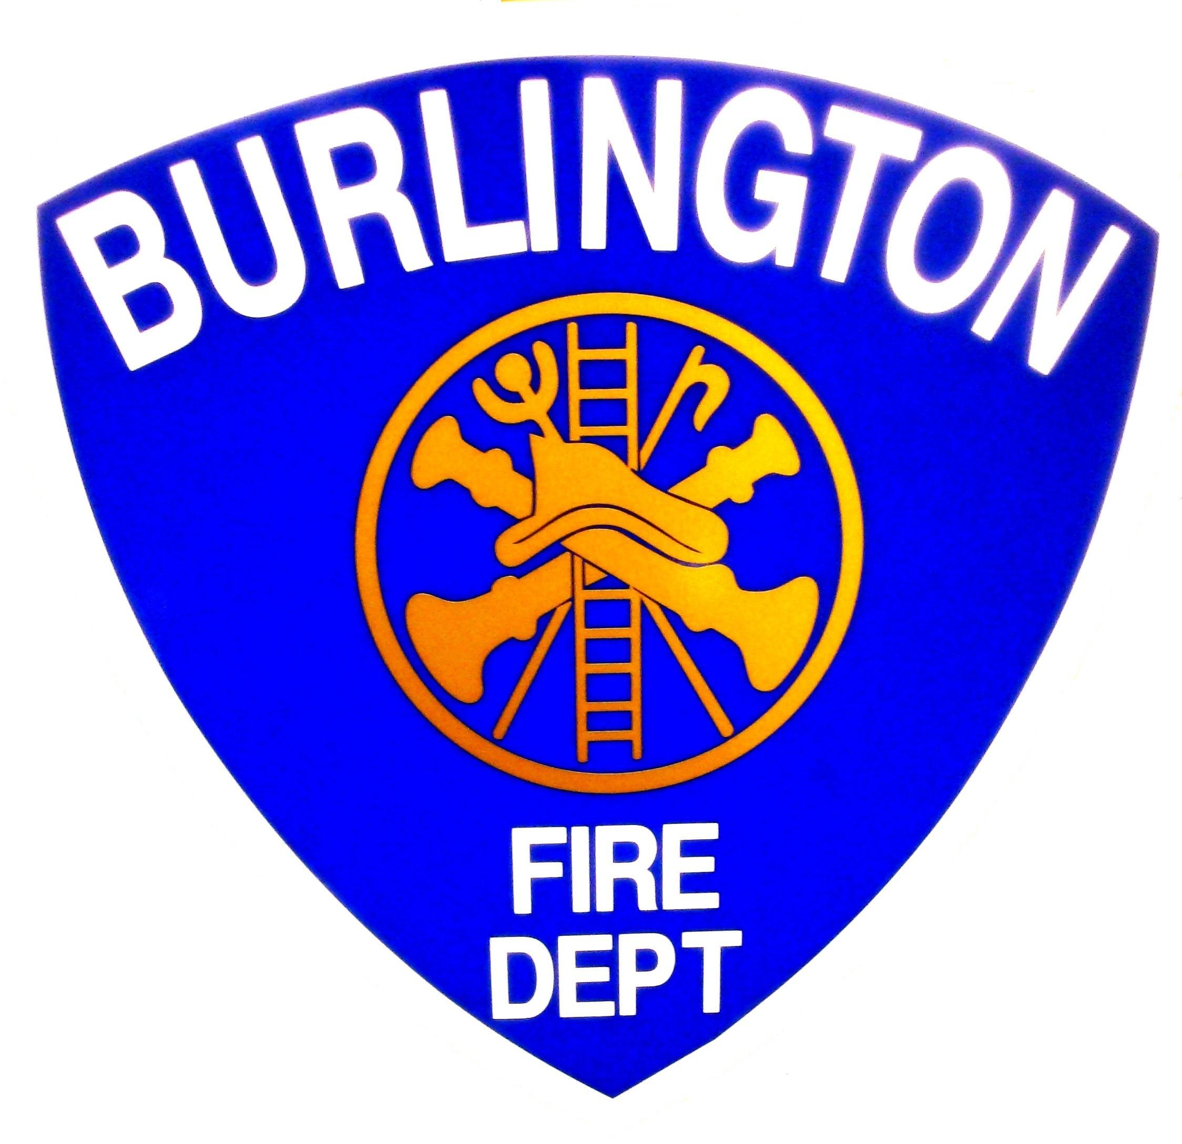
Michael E. O'Neil
Chief Engineer
Michael E. O'Neil
Michael E. O'Neil
132 North Avenue, Burlington Vermont 05401
(802) 864-5577 Fax (802)658-7665
Burlingtonfire.net

Residential Smoke Alarms In the City of Burlington
Effective November 25, 2009

The Impact of Smoke Alarms
In the 1960's, the average U. S. citizen had never heard of a smoke alarm. By 1995, an estimated 93 percent of all American homes - single - and multi- family, apartments, nursing homes, dormitories, etc. - were equipped with alarms. In the event of a fire, properly installed and maintained smoke alarms will provide an early warning signal to your household. This alarm could save your own life and those of your loved ones by providing the chance to escape.

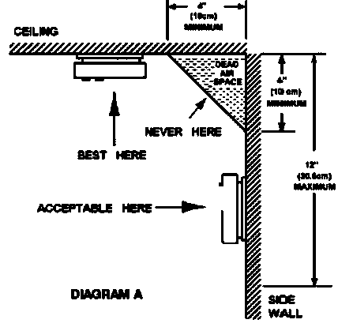
The installation of smoke alarms (detectors) must be in accordance with the manufacturer's instructions, Chapter 13-5 of the Burlington Code of Ordinances and NFPA 72, the National Fire Alarm Code, Section 72:11.8.3.5 which lists specific location requirements to improve reliability and avoid false alarms. Smoke alarms (detectors) must:

4” in
Min

- be installed in every bedroom and on every level of the home,
- be interconnected so that any alarm causes all of the devices to alarm,
- be powered by the building electrical system and have battery backup,
- not be located where the humidity and temperature are outside of the limits specified by the manufacturer,

4” in
Min
- not be located where temperatures fall below 40 degrees or exceed 100 degrees,
- be mounted on an inside wall or ceiling where outside walls or ceilings are poorly insulated,

12”
Max
Example of Proper Mounting for Smoke Alarms
NFPA Figure 72: A.5.6.3.1
- be photoelectric, or have alarm-silencing, when installed within 20 feet of a cooking appliance,
- not be installed within 36 inches from a door to a kitchen or bathroom containing a shower or tub,
- not be installed within 36 inches from a supply register of a forced hot-air heating or cooling system,
- not be installed within 36 inches from the tip of a blade of a fan suspended from a ceiling,
- be located in a stairway so that an intervening door or obstruction does not prevent rising smoke from reaching the alarm (detector),
- be located on the basement ceiling near the entry to the stairs.

Why should my home have smoke alarms?
In the event of a fire, a smoke alarm can save your life and those of your loved ones. They are the single most important means of preventing house and apartment fire fatalities by providing an early warning signal -- so you and your family can escape.

Can I install combination alarms?
The law allows for the installation of combination smoke and carbon monoxide alarms, but not for combination photoelectric and ionization alarms.

What if the alarm goes off while I'm cooking?

Then it's doing its job. Do not disable your smoke alarm if it alarms due to cooking or other non-fire causes. You may not remember to put the batteries back in the alarm after cooking. Instead, clear the air by waving a towel near the alarm, leaving the batteries in place. The alarm may have to be moved to a new location.

Where do I put them?

Install smoke alarms in every bedroom and on every level of your home, including the basement. Most fire fatalities occur between 2 a.m. and 6 a.m. when most people are sleeping. Contrary to popular belief, the smell of smoke may not wake a sleeping person. Instead, the poisonous gases and smoke produced by a fire can dull the senses and put one into a deeper sleep. The only thing standing between the deadly fumes of a fire and a safe escape is the piercing sound of a smoke alarm.

Cooking food or steam from the shower may result in frequent nuisance alarms. Consider moving the alarm or using a smoke alarm with a "hush" feature for smoke alarms located near these areas.

Updating Smoke Alarms

Smoke alarms don't last forever. Smoke alarms need to be Replaced every 10 years.

If your smoke alarms are 10 years old or more it’s time to replace them with new photoelectric ones.

There’s a label on the alarm with the date of manufacture. If it doesn’t have a label, it’s already more than ten years old.
Smoke alarms need to be properly installed, maintained and replaced when needed.

Many hardware, home supply or general merchandise stores carry smoke alarms. Make sure the alarm you buy is a photoelectric style and is UL-listed. If you are unsure where to buy one in your community, call your local fire department (on a non-emergency telephone number) and they will provide you with some suggestions.

No home should be without smoke alarms, and ionization alarms should continue to be used until a home can be equipped with new photoelectric alarms. And remember installation of an early warning smoke alarm system combined with a well-rehearsed plan for escape may save the lives of you and your family.

= Required Location = Optional Location = Optional HUSH style

All Homes

How long will my smoke alarm last?

About eight-to-ten years, after which it should be replaced. Like most electrical devices, smoke alarms wear out. You may want to write the purchase date with a marker on the inside of your unit. That way, you'll know when to replace it. Always follow the manufacturer's instructions for replacement.

How do I take care of my smoke alarms?

Smoke alarms are pretty easy to maintain. Unfortunately, improper maintenance is a big reason smoke alarms fail. According to a study by the Consumer Product Safety Commission, 90 percent of U.S. households have smoke alarms. However, the smoke alarms in 20 percent of these households - about 16 million - weren’t working.

This sheet is designed to promote fire prevention, code compliance and to enhance the public safety of the residents of Burlington, Vermont. This sheet provides a detailed overview of one common issue and is not an all-inclusive list of state laws, municipal ordinances or additional code requirements that may apply. For additional information or details you should contact the Burlington Fire Department, Office of the Fire Marshal at 864-5577.
This sheet was developed as an educational resource with information provided from the National Fire Protection Association (NFPA) and the Vt Division of Fire Safety.

Requirements of the

Code of Ordinances of the City of Burlington

Sec. 13-5. Smoke detectors.
(a) Each and every dwelling, rooming house, dwelling unit or rooming unit used for occupancy shall meet the following requirements for smoke detectors/alarms.
(1) Smoke detectors/alarms shall be installed in the following, areas:
(A) In every sleeping room or area;
(B) Outside every sleeping room or area in the immediate vicinity of the sleeping room or area; and
(C) On all levels of the dwelling, dwelling unit, rooming house, or rooming unit, including basements but excluding crawl spaces and unfinished attics.
(D) Notwithstanding the above installation locations, detectors/alarms shall not be located within kitchens or garages or in other spaces where temperatures can fall below forty (40) degrees F (four (4) degrees C) or exceed one hundred (100) degrees F (thirty-eight (38) degrees C). Detectors/alarms shall not, unless specifically listed for the application, be located closer than three (3) feet (0.9 m) horizontally from:
(i) The door to a kitchen.
(ii) The door to a bathroom containing a tub or shower.
(iii) The supply registers of a forced air heating or cooling system, and outside of the airflow from those registers.
(2) Smoke detectors/alarms shall receive their operating power from the building electrical system but shall also receive power from a battery when the building electrical system power is interrupted.
(3) Smoke detectors/alarms within each dwelling unit or rooming unit shall be interconnected so that the sensing of smoke by one detector sounds the alarms of all detectors within that dwelling unit or rooming unit.
(4) Smoke detectors/alarms shall be approved or listed by a nationally recognize testing or listing agency for the purposes for which they are intended and conform with the requirements of the Vermont Fire and Building Safety Code.
(5) Smoke detectors/alarms shall be properly installed and shall be maintained in good working condition.
(b) All other dwellings, rooming houses, dwelling units or rooming units not covered by (a) shall have a smoke detector/alarm installed in compliance to the Vermont Fire and Building Safety Code. Such smoke detectors/alarms shall be approved or listed by a nationally recognized testing or listing agency for the purposes for which they are intended.
(c ) If a smoke detector is disconnected or disabled, that fact shall create a rebuttable presumption that the adult occupants of the dwelling unit were responsible for the act of disconnecting or disabling the smoke detector.
(d) No requirement of this section shall preclude the application of other more restrictive smoke detector requirements which may pertain to the property, including but not limited to, time of sale requirements pursuant to state law.

