Vermont Department of Public Safety
OFFICE OF THE STATE FIRE MARSHAL, THE STATE FIRE ACADEMY AND THE STATE HAZ-MAT TEAM
WWW.VTFIRESAFETY.ORG

CIS-12

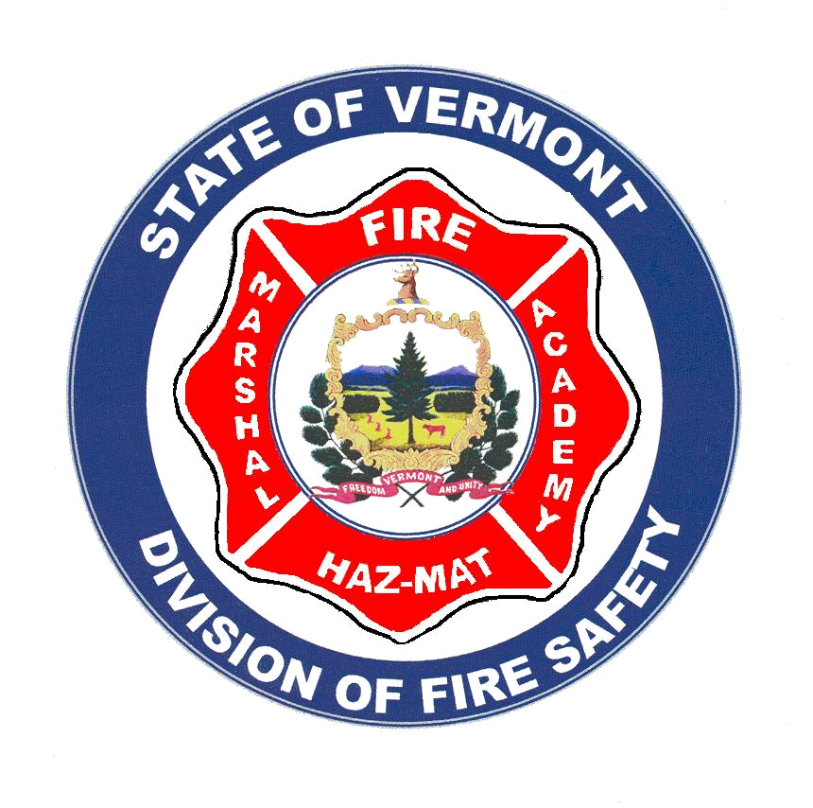
2010

CODE INFORMATION SHEET

Updated December 2009

BARBECUE GRILLS

FIRE CODE CHANGES AIM TO REDUCE FIRES FROM BARBECUE GRILLS – Everyone loves a barbecue, Gas and charcoal BBQ cooking grills have become an essential part of our lifestyle. Unfortunately, cooking on gas and charcoal grills can also be dangerous. The use and storage of solid fuel or propane cooking equipment on patios and balconies has resulted in a number of major fires in the state of Vermont.

As with other types of cooking devices, the leading causes of structure fires involving charcoal-fueled grills are unattended cooking and placing combustibles too close to heat. In structure fires, the first items ignited are most commonly the exterior trim and wall coverings. The leading cause of gas-grill fires is attributed to failure of the equipment or breaks in the gas lines of the equipment.

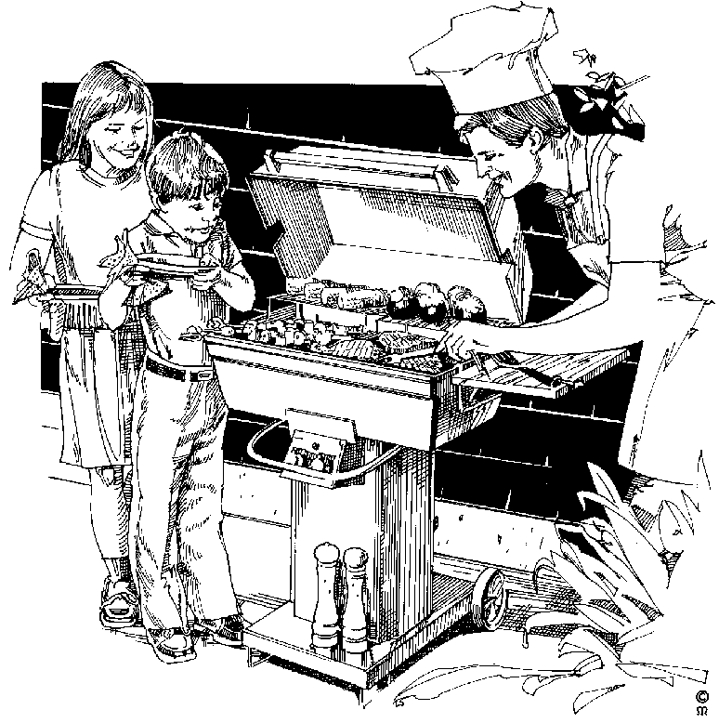
Before firing up the grill, there are several safety precautions and fire code requirements to keep in mind. By following these guidelines, you'll help prevent possible gas explosions or fires.

Here are a few tips that can help make barbecuing safer.

• Charcoal briquettes should be stored in a dry area because damp or wet charcoal is sensitive to spontaneous heating.

• The use and storage of barbecue grills should be restricted to the out-of-doors. Never use barbecue grills for home heating or indoor cooking.

• Charcoal briquettes should be allowed to cool naturally a safe distance from structures and combustible materials and then properly disposed of.

• Charcoal lighter fluid should be properly stored, away from living areas of the home.

•Propane cylinders should be stored outside at least 20 feet from building openings such as windows and doors.
• Check grill hoses for cracking, brittleness, holes, and leaks. Make sure there are no sharp bends in the hose or tubing.

• Never bring the propane tank into the house. Store cylinders and grills with cylinders attached in a shaded, cool area out of direct sunlight.

• Charcoal and gas grills are sources of Carbon Monoxide. CO fumes are odorless and can quickly overwhelm you in an enclosed space.

Use only LP containers equipped with an Overfill Protection Device

The state of Vermont has adopted the 2006 NFPA Uniform Fire Code that includes regulations concerning grills on and near combustible decks and structures. The new code contains the following code requirements concerning these appliances.

Requirements of the 2006 VERMONT FIRE & BUIDING SAFETY CODE
For other than one- and two-family dwellings, no hibachi, gas-fired grill, charcoal grill, or other similar devices used for cooking, heating, or any other purpose, shall be used or kindled on any balcony or under any overhanging portion or within 10 ft (3 m) of any structure. Listed electric ranges, grills, or similar electrical apparatus shall be permitted.
[ NFPA 1 : Sec10.11.7 ]

Open fires and cooking fires shall be constantly attended by a competent person until such fire is extinguished. This person shall have a garden hose connected to the water supply or other fire-extinguishing equipment readily available for use.
[ NFPA 1 : Sec10.11.3 ]

Anytime you’re dealing with a force as explosive as several sticks of dynamite, caution must be taken.
The propane cylinders that are used to fuel gas grills are just this explosive.

For your own safety, take the time to learn how to handle them safely.

This sheet is designed to promote fire prevention, code compliance and to enhance the public safety of all Vermonters. This sheet provides a detailed overview of one common issue and is not an all-inclusive list of state laws or additional code requirements that may apply. For additional information or details you should contact an Asst. State Fire Marshal in your regional office of the Division of Fire Safety. This sheet was developed as an educational resource with information provided from the National Fire Protection Association (NFPA)
Division of Fire Safety Regional Offices
Barre 802-479-4434 * Rutland 802-786-5867 * Springfield 802-885-8883 * Williston 802-879-2300
ww.vtfiresafety.org

