Planning Department
Planning Commission, Councilors Mason, Bushor, Paul: Ordinance Committee

Thirteen

COMPREHENSIVE DEVELOPMENT ORDINANCE—
Garage Size and Orientation
ZA #13-04

That Appendix A, Comprehensive Development Ordinance, of the Code of Ordinances of the City of Burlington be and hereby is amended by amending Sections 4.4.5, Residential Districts, and 6.2.2, Review Standards, thereof to read as follows:

Sec. 4.4.5 Residential Districts

(a) through (c) As written.

(d) District Specific Regulations:
1. through 3. As written.

4. Accessory Residential Structures and Uses
An accessory structure and/or use as provided under Sec. 5.1.12 and 5.1.2 customarily incidental and subordinate to a principal residential use, including but not limited to private garages, carriage houses, barns, storage sheds, tennis courts, swimming pools, cabanas for swimming pools and detached fireplaces may be permitted as follows:
- Accessory Structures shall meet the dimensional requirement set forth in the district in which they are located pursuant to Sec. 4.4.5(b) of this Article and related requirements in Art 5, Part 2.;
- Any accessory structure that is seventy-five fifty percent (750%) or greater of the ground floor area of the principle structure shall be subject to the site plan and design review provisions of Art 3, Part 4 and the applicable standards of Art 6.;
2

COMPREHENSIVE DEVELOPMENT ORDINANCE—
Garage Size and Orientation
ZA 13-04

- Private garages shall be limited to as many stalls as there are bedrooms in the dwelling to which it is accessory, provided that the ground floor area is less than fifty seventy-five percent (750%) of the ground floor area of the principal structure.;
- The outdoor overnight storage of commercial vehicles not otherwise associated with an approved home occupation or made available for the exclusive use of the residential occupants, or the outdoor storage of more than one unregistered vehicle, shall be prohibited. Any and all vehicles shall be stored in an approved parking space.; and,.
- Accessory structures such as doghouses, doll houses, or tree houses that are less than or equal in the aggregate to a total of sixteen (16) square feet in area shall not require a zoning permit.
- Uncovered play structures, seasonal skating rinks, raised planting beds shall not require a zoning permit.
5. through 7. As written.

Sec. 6.2.2 Review Standards

through (g) As written.

(h) Building Location and Orientation:
The introduction of new buildings and additions shall maintain the existing development pattern and rhythm of structures along the existing streetscape. New buildings and additions should be aligned with the front façade of neighboring buildings to reinforce the existing “street-edge,” or where necessary, located in such a way that complements existing natural features and landscapes. Buildings placed in mixed-use areas where high volumes of pedestrian traffic are desired should seek to provide sufficient space (optimally 12-15 feet) between the curbline and the building face to facilitate the flow of pedestrian traffic. In such areas, architectural recesses and articulations at the street-level are particularly important, and can be used as an alternative to a complete building setback in order to maintain the existing street wall.
3

COMPREHENSIVE DEVELOPMENT ORDINANCE—
Garage Size and Orientation
ZA 13-04

Principal buildings shall have their main entrance facing and clearly identifiable from the public street. The development of corner lots shall be subject to review by the city engineer regarding the adequacy of sight distances along the approaches to the intersection. To the extent practicable, development of corner lots in non-residential areas should try to place the building mass near the intersection and parallel to the street to help anchor the corner and take advantage of the high visibility location.
In residential areas, aAccessory buildings shall be located in such a way so as to be deferential and secondary and subordinate in scale and design to the principal structure. Under no circumstances shall aA parking structure – either attached or detached – shall be located closer to setback the front property line than from a the longest street-facing wall of the principal residential structure, and be deferential yet consistent in character and design. and w Where a front yard setback is required, any street-facing garage wall containing garage doors shall be set back a minimum of 25’ from the front property line to prevent parked vehicles from blocking the public sidewalk. Where a garage is not oriented towards the street (i.e. the garage doors face the rear or side of the property yard), the street-facing garage wall shall have windows or doors or other features that break-up the mass into smaller elements, and be blended with the character of the residential portion of the structure.
Where a garage is attached to a principal single-family or duplex residential structure and oriented to the street (i.e. the garage doors face the street) the following standards shall apply:

4

COMPREHENSIVE DEVELOPMENT ORDINANCE—
Garage Size and Orientation
ZA 13-04

- Except as provided in subsections 2 3, 4 and 3 5 below, a street-facing garage wall should shall constitute no more than 3050% of the length width of the street-facing façade of the entire structure (including the garage portion), and shall not exceed 3024-feetor 35% whichever is less. In cases where a street-facing garage wall constitutes between 30%-50% of the street-facing façade, living space is encouraged above to integrate the garage more closely into the design and mass of the overall structure. In cases where the street-facing garage wall constitutes more than 50% of the width of the street-facing façade, living space above is required.
2. Each bay of the garage shall have a separate entrance door of no more than 10-feet in width.
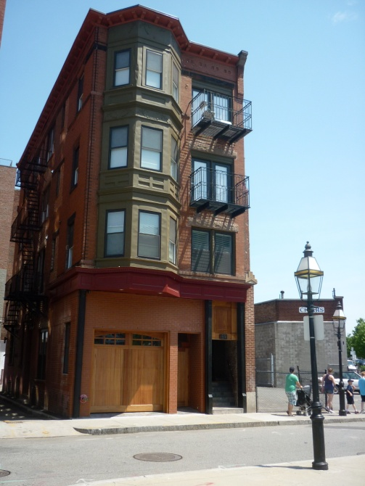
2. 3. Where the width of the street-facing façade of the residential portion of the entirestructure is less than 35 14 feetlong, the street-facing garage wall portion may be allowed up to but not exceeding 14 feet long in order to allow for a single garage bay.

5

COMPREHENSIVE DEVELOPMENT ORDINANCE—
Garage Size and Orientation
ZA 13-04

4. Where a garage entrance is within a single roofline and wholly integrated into the overall design the front façade of the structure, it may constitute more than 50% of the width of the street-facing façade provided there is interior living space above, and the primary pedestrian entrance offers a clear and welcoming entrance from the street.
3. 5. Enclosed space originally designed and constructed as a garage for vehicular parking but converted to living space may be converted back to enclosed vehicular parking provided there is no expansion of the building footprint necessary to complete the conversion.
Balance of Sec. 4.4.5 As written.

* Material stricken out deleted.
** Material underlined added.

lb/KJS/c: Ordinances 2013/Zoning Amendment – Garage Size and Orientation ZA #13-04, Sec. 4.4.5, 6.2.2
3/6/13

